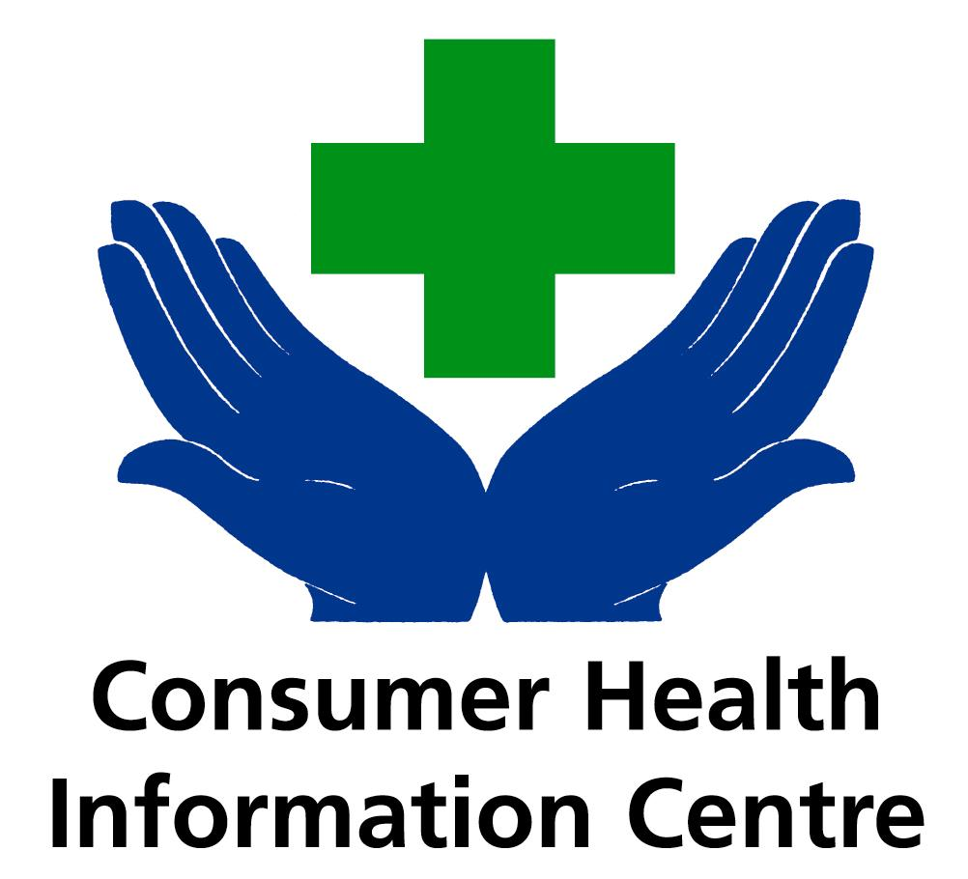

Do not use before: Friday 28th June

Don’t let grass ruin your festival -

Hayfever leaflet launched at Glastonbury

Summer festival-goers prone to hayfever are being advised to down-load a new e-leaflet from the net at www.chic.org.uk to survive festivals in fields this summer. Hayfever – Are you treating it right? is being launched by CHIC (Consumer Health Information Centre) at Glastonbury’s Festival Pharmacy (28th – 30th June). The leaflet contains a simple ‘Treatment Tree’ to guide people through hayfever symptoms and the most effective treatment options.

CHIC Adviser, pharmacist Gerald Zeidman, said that some people who get hayfever need to treat their symptoms continuously throughout the season for treatment to be effective. ‘Many people who come in to my pharmacy with hayfever symptoms tend to treat it on an ad-hoc basis. However, for some, the most effective way to tackle it is to use hayfever products continuously throughout the season – even if their symptoms are not always apparent.’

Gerald Zeidman pointed out that one of the key pieces of advice for people who get hayfever is to stay away from grassy areas: not possible at a summer festival! ‘Self-help advice for hayfever, such as avoiding pollen, is valuable – but not always realistic for people who enjoy outdoor summer activities. CHIC’s advice to them would be to talk to their pharmacist and make sure they’re treating their hayfever right.’

Some 3 million people are affected by hayfever in Britain every year. Symptoms range from sneezing, runny and blocked nose, to tickly throat, itchy palate and watering eyes.

~~~ CHIC is also sponsoring t-shirts for Glastonbury’s Festival Pharmacies and medical centre in support of Hayfever – treat it right!

Ends

Copies of the e-leaflet ‘Hayfever – Are you treating it right?’ can be down-loaded at www.chic.org.uk

FOR MORE INFORMATION CALL JULES MOAR ON 07970 480 832

Notes to Editor
Distribution of the leaflet is being supported by Pfizer. The leaflet will be distributed at balloon and garden festivals around the UK this summer, where the Benadryl hot-air balloon will be flying.

The Consumer Health Information Centre was established in 1997 to help improve people’s understanding of common ailments and to offer guidance on how they can improve the management of their own health. CHIC has identified the need to raise awareness of health and self-treatment issues after extensive research among the general public.

