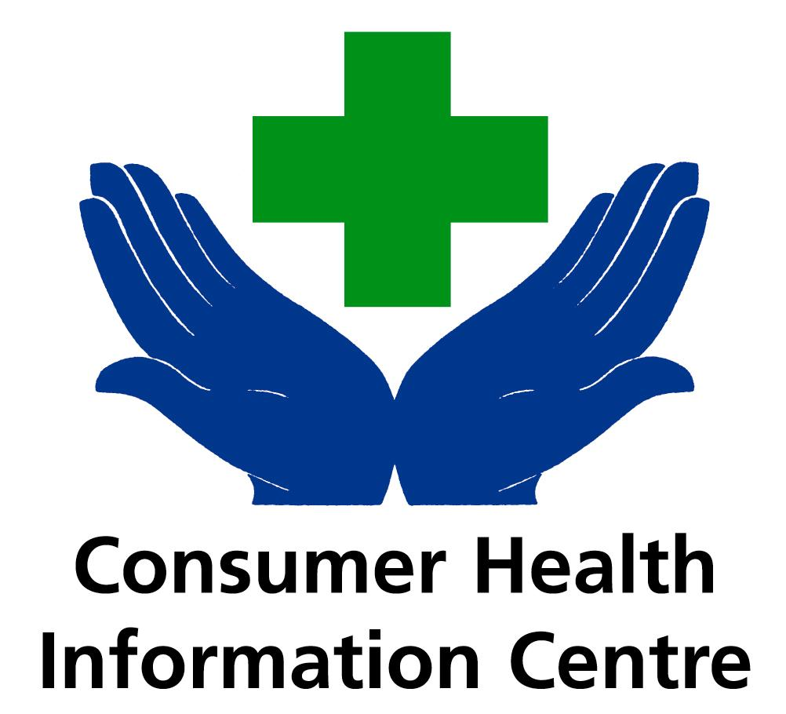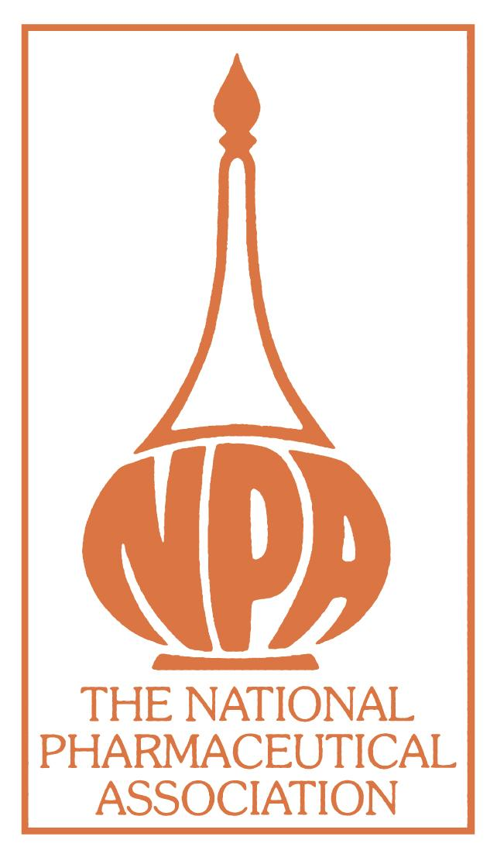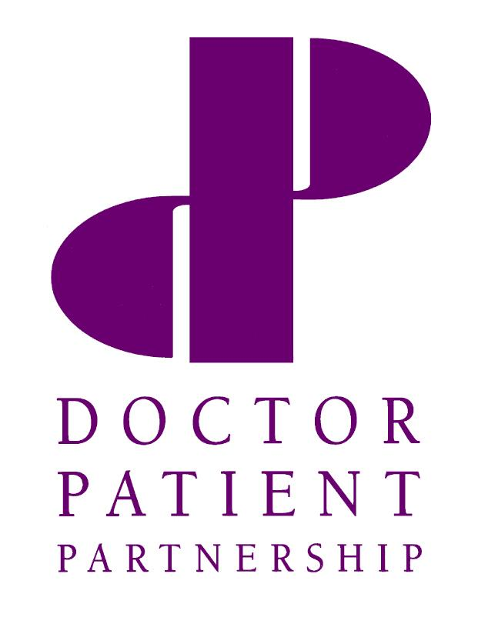

For immediate use: 5th March 2002

Patients keen to take responsibility for their medical records

New research out today (5/03/02) shows that patients are ready and willing to be responsible for their own medical records; see their current medical records and share their drug information with pharmacists.

Research, carried out by NOP Research on behalf of the Doctor Patient Partnership and the Consumer Health Information Centre, found that almost two-thirds (63%) of people said they would like to be responsible for holding their own medical records on a small electronic ‘smart’ card (not yet an option in the UK), with 69% indicating they would be willing to have the responsibility of producing the records on visits to their GP or a hospital.

Although most people (73%) are aware that they can access their medical records if they need to, the majority (87%) are not aware that they can be charged up to £10 to read their medical records, And almost two-thirds (62%) of people didn’t realise that they could expect to pay up to £50 to have a copy of their medical records*. The charges meet the time and administration costs incurred by the surgeries.

These findings mark the launch of a joint campaign ‘Your Medical Records’ to inform patients about how to gain information from their medical records and the cost implications, whilst raising awareness of the benefits to patients and health professionals of sharing health and drug information.

Dr Simon Fradd, Chairman, Doctor Patient Partnership, says that the campaign aims to create a ‘transparency of information’ between patients and health professionals. ‘It is important that people are aware that they can access their medical records, and that there will be a charge to cover the GP’s expenses to complete the task. Only if patients are clear about the process, can they make their own choices about their medical records.’

...more...

..2/2..

Encouragingly, almost half (49%) of those asked said they always tell their pharmacist about other medicines they are taking when they buy non-prescription medicines from a pharmacy. Gerald Zeidman of the Consumer Health Information Centre says that this is important to ensure patients receive safe, effective and appropriate care. ‘Pharmacists have an extensive, in-depth knowledge of medicines and are well-placed to advise people on the safety and effectiveness of prescription and non-prescription medicines,’ he says.

Mr Zeidman explains that, when buying over the counter medicines, it is important for patients to check that there are no possible interactions with any other over the counter or prescribed medication they are taking. Also, some over the counter and prescription medicines contain the same ingredients that could cause an overdose in some cases if taken together. ‘ A short discussion with the pharmacist will ensure that patients receive the best possible advice,’ Mr Zeidman says.

Posters containing information on accessing medical records are being displayed in surgeries and pharmacies across the UK. To help patients record their prescription and non-prescription medicines for discussion with a pharmacist or GP, Patient Medicine Cards are being placed in GP surgeries and pharmacies. Ends

Contacts:
Consumer Health Information Centre Jules Moar: 07970 480 832; email: jules.moar@pagb.co.uk,
Doctor Patient Partnership Pam Prentice: 020 7383 6144, out of office hours 0780 3399826, pprentice@bma.org.uk

Notes to Editor
* If copies of medical records are requested, where at least part of the information is held manually, a fee of up to £50 may be charged to cover the time and costs involved.
- The DPP/CHIC research was carried out by NOP Solutions, 2002. A sample of 1000 adults 15+ who are nationally representative of the British population were collected.
- The Consumer Health Information Centre was established in 1997 to help improve people’s understanding of common ailments and to offer guidance on how they can improve the management of their own health. CHIC has identified the need to raise awareness of health and self-treatment issues after extensive research among the general public.
- The Doctor Patient Partnership (DPP) is an independent charity that produces regular education campaigns for the UK’s general public and health professionals.
- The campaign is being supported by the National Pharmaceutical Association (NPA). NPA represents the owners of 11,000 pharmacies in the UK. It has in voluntary membership, virtually all pharmacies, except Boots the Chemist. It is therefore the principal body representing the community pharmacy sector.

